MAX
SELECT MAX(NET_SALARY) FROM EMPLOYEE1;
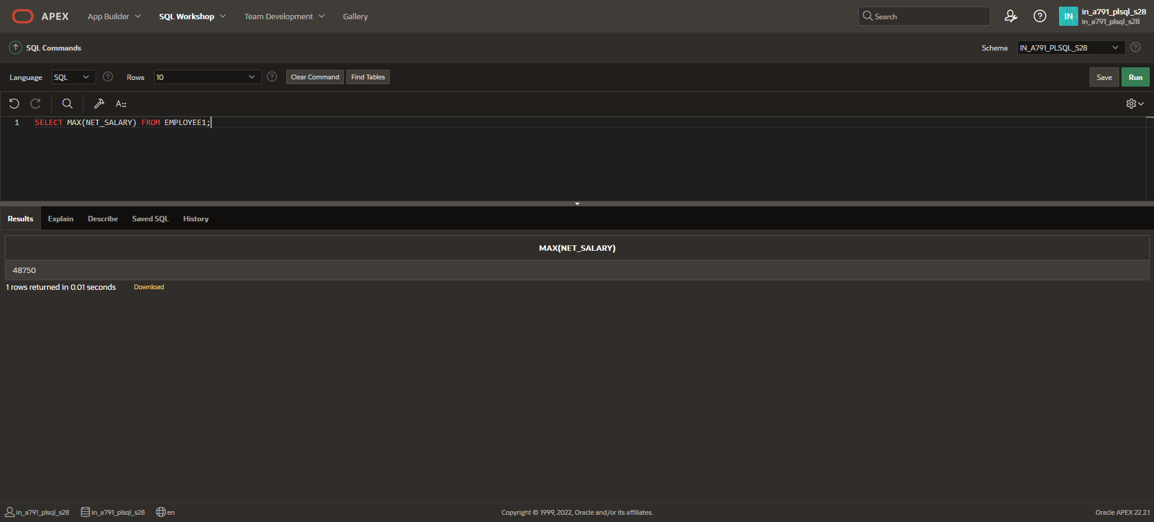
MIN
SELECT MIN(NET_SALARY) FROM EMPLOYEE1;
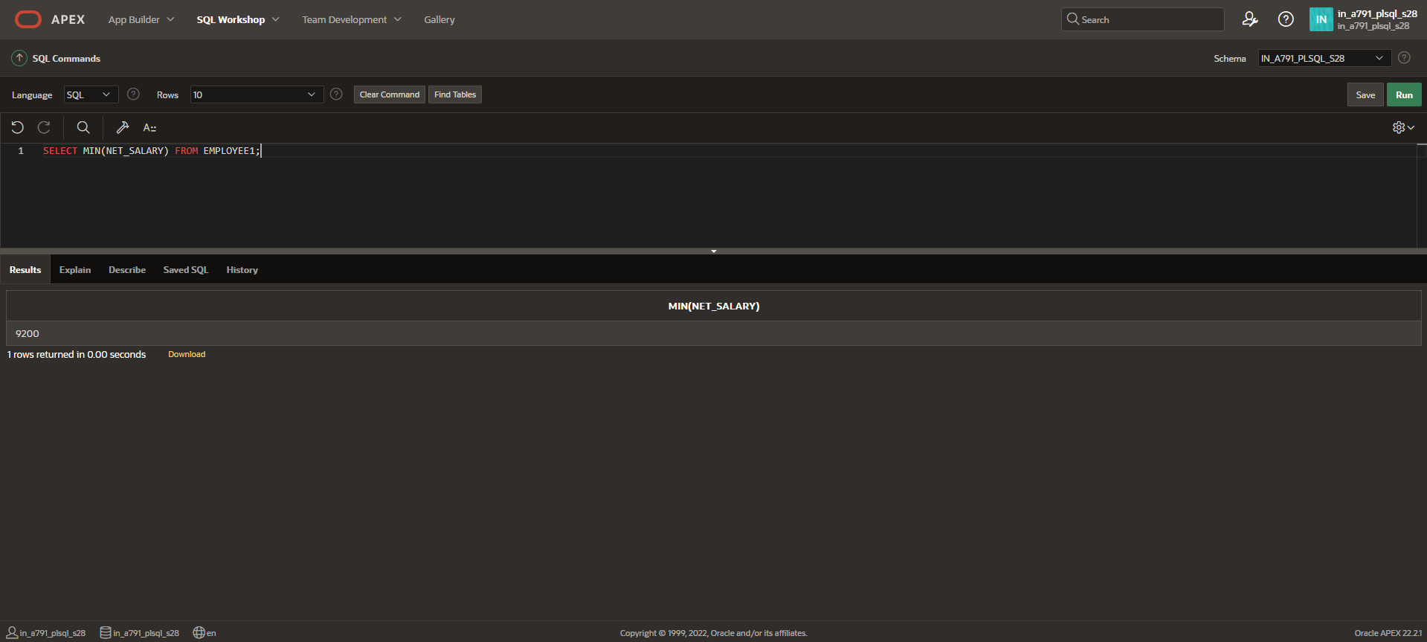

AVG
SELECT AVG(NET_SALARY) FROM EMPLOYEE1;
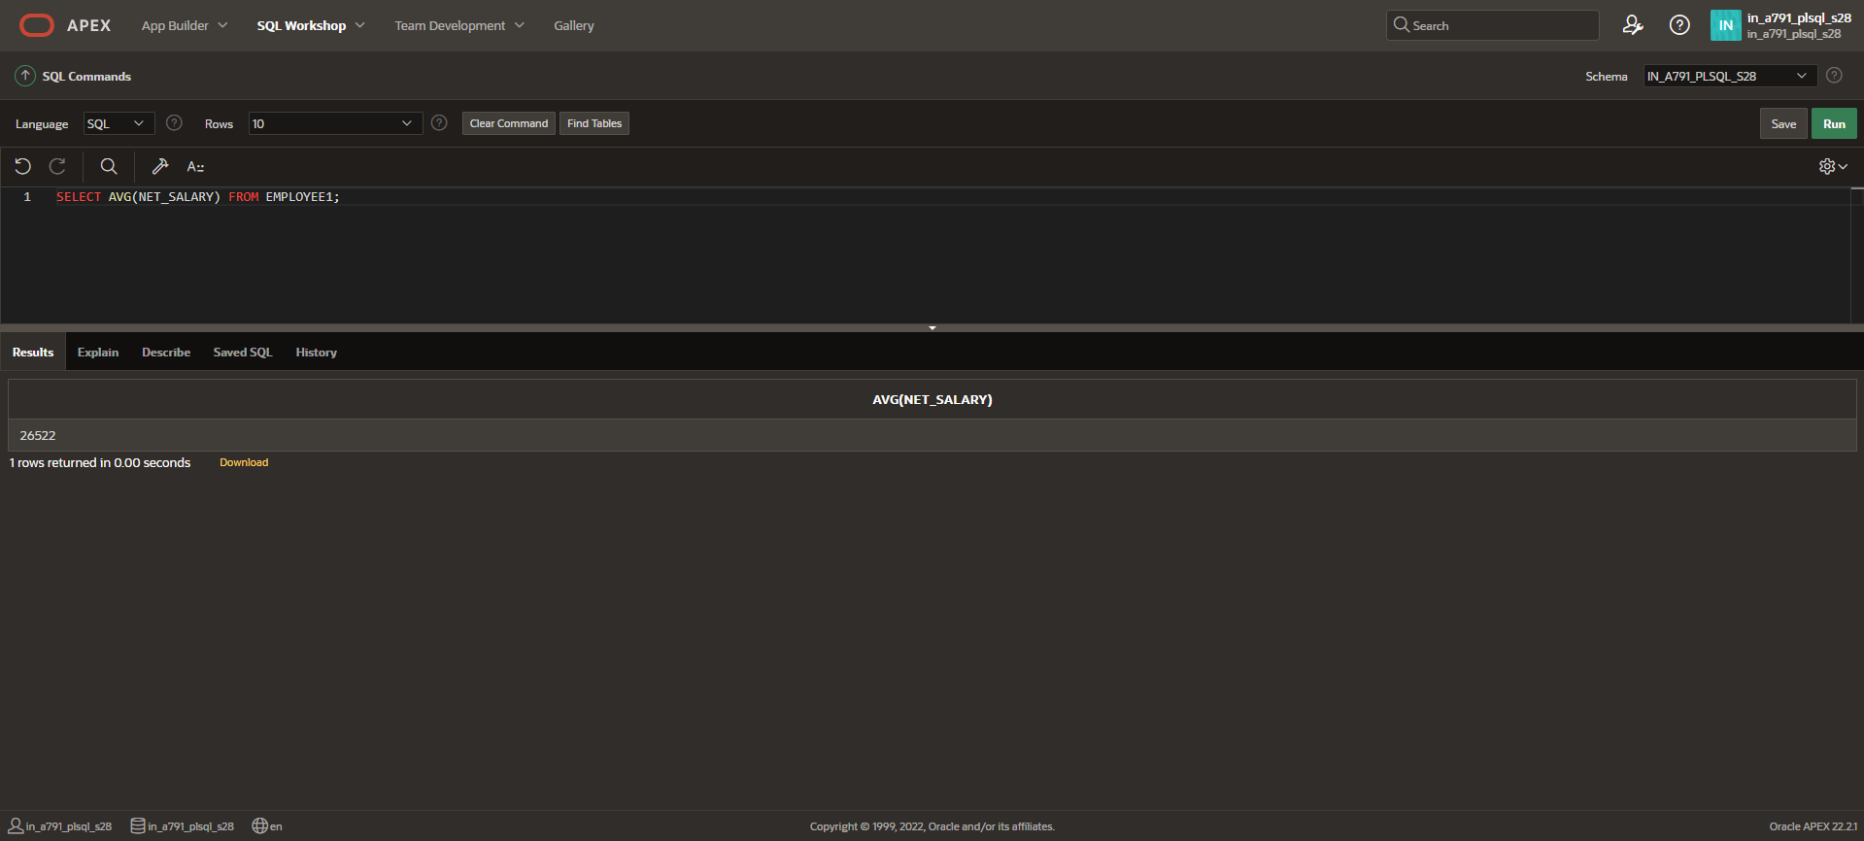
SUM
SELECT SUM(NET_SALARY) FROM EMPLOYEE1;
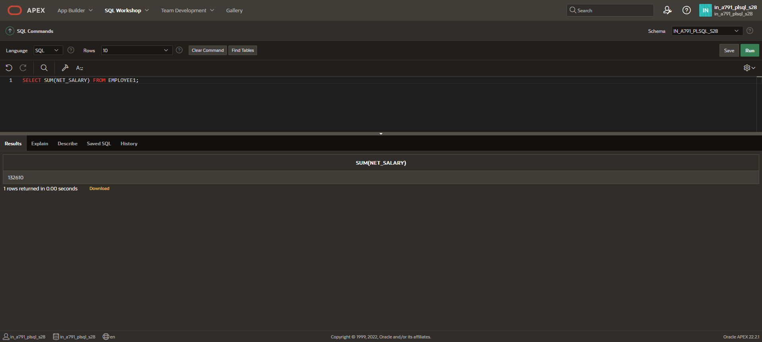

COUNT
SELECT COUNT(NET_SALARY) FROM EMPLOYEE1;
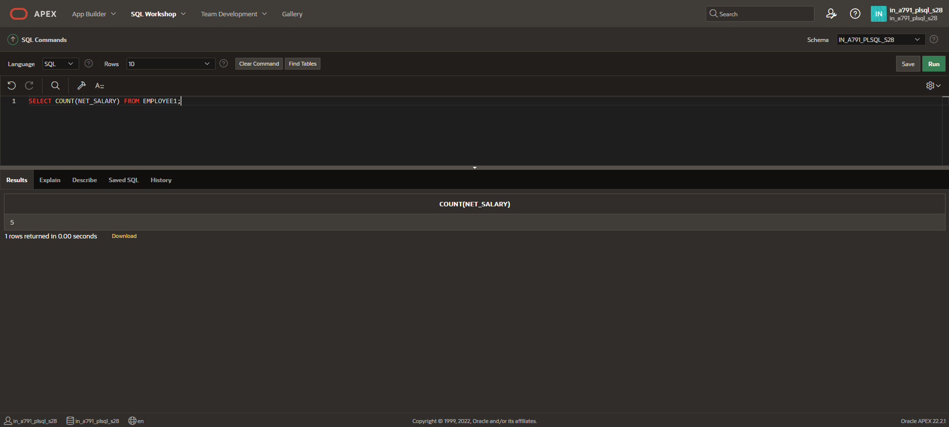
VARIANCE
SELECT VARIANCE(TAX) AS VARIANCE FROM EMPLOYEE1;
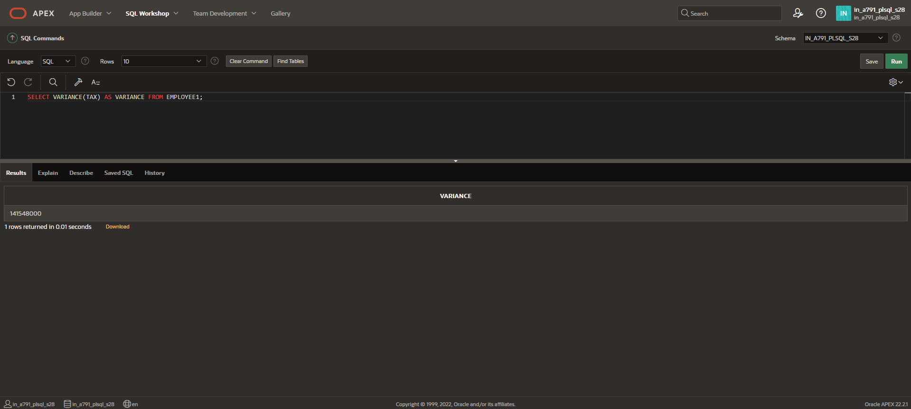

STDDEV
SELECT STDDEV (NET_SALARY) AS VARIANCE FROM EMPLOYEE1;
